SFI Communications Plan
Key Concepts for 2015

- Overview
- Target audiences: conservationists and brand owners
- Strategic direction and communications
  - Elevate conservation value
  - Fostering community engagement
  - Positioning SFI as a proof point of responsible forestry
  - Growing certified supply
  - Strengthening market access and global relevance
- Activities to support communications
  - Grants programming and communications
  - SFI presence at recent brand owner events
  - SFI presence at future brand owner events
- Communications channels
- Communications tools
- Measurement activities to support communications
  - Timeframe and content sources
  - Article type
  - Mention type
  - Tone
  - Publication tier
  - Topic
- Media and communications spokespersons

- Overview
At the Sustainable Forestry Initiative (SFI), we believe the future of our forests and our shared quality of life depend on strengthening the vital links between healthy forests, responsible purchasing and sustainable communities.

Over the last 20 years, the SFI Standards, the SFI community, and the SFI programs have evolved, improved, and have made a considerable contribution to our shared quality of life. While globally, many are focused on minimizing the risks and guilt of using forest products, we are focused on a future where the global community has addressed deforestation and illegal logging, and takes pride in purchasing forest products derived from a responsibly managed renewable resource.

SFI’s standards, its diversity, its conservation efforts and its community initiatives are at the heart of the organization and are what make SFI unique among sustainability certifications. As such, making sure that our key audiences as well as the broader public know and understand the breadth of our work is a critical part of our success.

- Target audiences: conservationists and brand owners
The SFI Board of Directors has given the mandate to use a conservation and brand owner lens to evaluate all communications activities, as these are the two most important target audiences for SFI.

- Strategic direction and communications
During 2014, SFI embarked on a process to develop a strategic direction that would build upon SFI’s core strengths and assets, enhance SFI’s position in the marketplace, positively influence competitive forces, and create long-term value for SFI’s community. The resulting 2015 work plan builds on that strategic direction foundation and frames the concrete implementation steps that will be taken in 2015. The Priority Action Areas are not listed in an order of priority, but rather are all equal and mutually reinforcing.

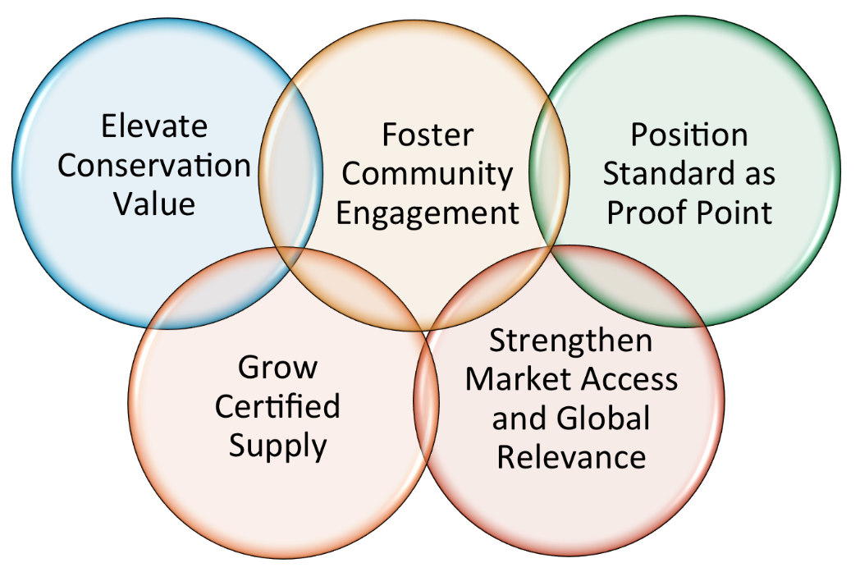
These Priority Action Areas are linked to communications targets and activities. In turn, each of these targets and activities are focused on elevating SFI’s profile with conservationists and brand owners.

  - Elevate conservation value: Develop communications strategy for elevating Conservation Grant Program.
Communications metrics:
- Positive media coverage of conservation-related SFI projects and partnerships
- Development of quantifiable and credible messages related to conservation value of SFI certified forests and fiber sourcing, with clear linkages to specific data
- Invitations by credible conservation partners to participate in symposia, workshops or collaborative discussions in 2015 related to central topics within the conservation community

  - Fostering community engagement: Explore new ways to use social media to elevate the profile of community partnerships. Continued management of community grant program and coordinate with partners on media opportunities.
Communications metrics:
- Social media platform (e.g. LinkedIn, Facebook, Twitter) is widely viewed and well-populated with community content from SICs
- Positive statements from at least two community organizations we support and/or work with
- Positive media coverage of community activities of SFI, SFI program participants, and SICs
- Positive coverage of and participation in at least two key indigenous events (Intertribal Timber Council, Canadian Council for Aboriginal Business)

  - Positioning SFI as a proof point of responsible forestry: Use the launch of the SFI 2015-2019 Standards and Rules to rebrand SFI in the conservation and brand owner communities as the proof point of responsible forestry.
Communications metric:
- Positive media coverage related to launch of new SFI 2015-2019 Standards and Rules.

  - Growing certified supply: Increase certified supply throughout the supply chain to strengthen SFI’s reach.
Communications metric:
- Deliver on SFI Forest Partners® Program and strengthen communications and market recognition.

  - Strengthening market access and global relevance: Remove barriers to market access and grow global recognition of the SFI brand, fiber sourcing, and labels.
Metrics
- Positive external quotes about SFI from corporations and government leaders
- Improved customer sentiment about the SFI program based on survey of brandowners (benchmark based on 2012 Harris survey)
- Positive SFI media coverage across U.S. and Canada on all aspects of SFI program
- Positive visibility for SFI in online search engines such as Google.
- Increase in number of participants at SFI annual conference (goal is 5% increase over 2014; final number TBD)

- Activities supporting communications
SFI communicates the relationships with, and support of, conservation organizations and environmental research to brand owners, in such a way that they may highlight conservation activities that are relevant and resonant to their supply chain and to their customers.

- Grants programming and communications
The success of the Conservation and Community Partnerships Grant Program provides SFI with a unique opportunity to focus, strengthen and reposition it as a platform for strategic growth, with increased revenue, focus, influence and effect. The Conservation and Community Grant Program will be the economic engine supporting the conservation and community work of SFI, while also helping to increase awareness of conservation and sustainable forest resource-based communities in the Organization’s brand and contribute to the credibility of SFI’s Standards.

- SFI presence at brand owner events including:
- Fortune Brainstorm Green – Senior SFI attended
- Green Biz Forum 15 - SFI provided sponsorship, participated in a webinar leading up to the Forum, staffed a booth, and senior staff participated and attended. Kathy participated on a panel at the GreenBiz Forum in Phoenix AZ with Jenny Cross from Mohawk Industries and Arthur Weissman of Green Seal. The discussion focused on The Future of Sustainability Labels and Certifications.

- On Feb. 10 leading up to the forum entitled "How Companies and Procurement Standards Can Protect Forests" with Kathy, former SFI Chair Larry Selzer – of the Conservation Fund and Dr. Beth Stevens - Walt Disney Company. 470 registrants signed up for the webinar.
- Sustainable Brands conference – Senior SFI Staff attended.

SFI has also provided articles on these organizations’ sites that would be of relevance to brands in connection to consumers and forest products.

- SFI presence at future brand owner events:
Grocery Manufacturers Association Sustainability Summit – Senior staff will attend
U.S. Green Building Expo International Conference and Expo - SFI will provide sponsorship of the “Women in Green Power Breakfast,” staff a booth focused on green building, and senior staff will attend.

- SFI presence at conservation based events (Past and Future)
In addition, SFI participates in a wide variety of state, provincial and national conservation workshops, conferences and discussion groups. A list of these events is available upon request.

- Communications channels
TreeHugger is the leading media outlet dedicated to driving sustainability mainstream. SFI works with TreeHugger team to regularly post articles of interest and relevance to reach a broad array of environmentally conscious consumers. Partial to a modern aesthetic, TreeHugger offers a one-stop shop for green news, solutions, and product information. It publishes an up to the minute blog, weekly and daily newsletters, and regularly updated Twitter and Facebook pages. Brandowners and conservation groups alike value the SFI content on the Treehugger site because it is consumer facing and demonstrates that SFI is reaching the everyday consumer with the messages of conservation, responsible forestry and procurement of forest products and how to make wise choices. SFI will be pushing out 20 stories, 5 videos and 5 infographics through the TreeHugger site in 2015, which elevates SFI in the eyes of the everyday citizen, brands, and conservation groups alike.

The 2015 Progress Report also celebrates the 20th anniversary and acts as a compelling summary of the progress SFI has made to date and its plans for future growth. The report includes year over year data, stories, history and accomplishments that constitute the SFI community across North America.

SFI 2015 Annual Conference: Growing the Future. SFI’s 2015 Annual Conference will celebrate 20 years of growth and change. The conference will feature some of the foremost thought leaders in the forest sector and highlight the SFI program's successes over the past 20 years and embrace the opportunities of the future. Each year our Annual Conference provides an opportunity for the SFI community — from landowner to brandowner, conservation and community organizations, university professionals and students, government agencies to resource professionals — to come together and learn about new research in conservation; renew partnerships and make new ones; and exchange ideas about how to improve forestry practices for the sake of healthy, thriving forests upon which all of us rely. In short the SFI Annual Conference is a time to connect, cooperate grow and improve.

SFI Inc. increasingly active on three primary social media platforms. SFI shares information and has conversations on Twitter with over 34,000 followers. SFI has also expanded its LinkedIn page to allow better connection with businesses and professionals. Most recently, SFI has become active on Facebook, using it for sharing SFI initiatives and the many diverse projects of the SFI community and partners.

- Communications tools
In addition to the SFI Progress report, which was produced in 2015, SFI produced additional tools and factsheets that can be used as leave behinds in meetings, conferences and tradeshows as well as given out to program participants and partners for their own communications needs. Some of these tools include:

Standard Launch tools:
- SFI 2015-2019 Standards and Rules Major Enhancements document
- SFI 2015-2019 Standards and Rules 1 pager
- SFI 2015-2019 Standards and Rules Q&A (FAQ)
SFI Factsheets:
- SFI Trifold Brochure
- SFI Fiber Sourcing Factsheet (in process)
- Greenbuilding factsheet
- Habitat for Humanity Wood 4 Good program factsheet
- SFI Market Relevance Factsheet
- Forest Partners Program Factsheets and individual southern state factsheets

- Measurement activities to support communications
SFI relies on media monitoring and impact surveys to evaluate the efficacy of communications efforts. On a quarterly basis consultants at Edelman Berland conduct targeted research on media coverage related to SFI and FSC.

This research explores the quality and quantity of the coverage within traditional news outlets, with the intent to demonstrate to SFI the successes and opportunities for improvement in its communications programs and set a benchmark regarding perceptions among key media.

  - Timeframe and content sources
- Coverage is sourced using standard Edelman Berland tools and represents online versions of daily newspapers, wires, local media, trade publications, and additional key online properties.
- For the SFI Annual 2014 Media Report, Edelman Berland collected 5,642 traditional news articles from online sources for SFI and 12,530 articles for FSC. This reflected a total volume of 17,033 articles, allowing for some coverage to include both organizations. These volumes have been used for the share of voice and volume over time charts.
- While industry standard is to sample to a 95% confidence level with a 5% margin of error, we improved on this. We set a minimum sample size of 1,470 to ensure that there was a broad cross-section of coverage. This translates to a 2.44% margin of error. In reality, we coded 538 relevant articles for SFI and 1,020 for FSC based on random sampling techniques. In addition we included some smart searches to ensure some validation to our findings.

  - Article type
Each article is assigned an article type — press release (including syndication) or non-press release reporting.

  - Mention type
Each article is assigned a mention type for SFI and FSC, including:
- Feature – SFI and/or FSC was the main point of discussion within the article
- Partial – SFI and/or FSC was detailed in the article but was not the primary focus
- Passing – SFI and/or FSC was mentioned in passing within the article and was not heavily detailed

  - Tone
Each article is assigned an overall positive, negative, or neutral rating based on the language used surrounding the portrayal of SFI and/or FSC.

  - Publication tier
Each publication is assigned a tier based on the following specifications:
- Tier 1 – Top 25 DMA according to Burrelles Luce Top Media List 2014; top national and trade publications according to Edelman
- Tier 2 – Local news affiliates and online news sources
- Tier 3 – Trade publications including Beltway, Biofuels, Printing, Packaging, Conservation & Environment, Forestry, Green Building, and additional trade sources

  - Topic
Each article is assigned one or more topics. Topics include:
- Market Access – Products using certified materials
- Standard for Responsible Forestry – Proof point for responsible forestry
- Sustainable Communities and Forests – Community engagement, youth outreach, First Nations discussion
- Forest Conservation
- SFI Independence – Strength of the board, diverse perspectives, diversity of user types
- Opposition Groups – Negative campaigns and organizations that work to undermine SFI

- Media and communications spokespersons:
SFI Staff Spokespersons:

- Kathy Abusow, President and CEO - high level and Tier 1 Media
- Elizabeth Woodworth, VP Communications & Community Engagement - high level and Tier 1, 2, 3 media and all other if appropriate spokesperson is not available
- Jason Metnick, Sr. VP Customer Affairs – Market, Customer, Brandowner audience opportunities
- Paul Trianosky, VP Conservation & External Affairs - US conservation and environmental opportunities
- Andrew de Vries, VP Conservation & Indigenous Relations - Canadian conservation and environmental opportunities and Aboriginal discussions/opportunities
- Nadine Block, COO & VP Government Affairs - government opportunities

In addition to SFI staff spokespersons, SFI utilizes a wide variety of surrogate voices to tell our story including:

- Board members
- SFI Conservation and Community Grantees and partners (grantees are required to publicly communicate information and developments with regard to their specific project).
- SFI Program Participants
- SFI MOU Partners
- Academics involved in SFI-related research and/or initiatives

